Origin | Dispersal
- Early forms of hockey originated in Ancient Egypt (4000 years ago), Ethiopia (1,000BC), Iran (2,000BC), Rome, Greek, Aztec, Arabs, Africans, and south Americans  - Egyptian tombs depict pictures of games similar to hockey which date back to 4000 years ago-  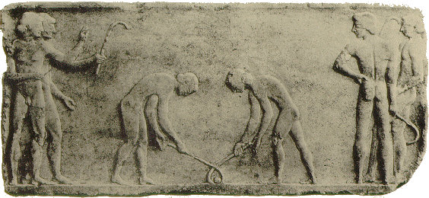  - Tomb of prince Kheti 2000 B.C at Neni-haman  - Many early games like hockey that feature a stick and ball-  - Hurling in Ireland and shinty in Scotland, played since 1272 B.C.  - Beikou in played in Mongolia at least 1000 years  - In South America (specifically Chile) in the 16th century used to play a game called chueca  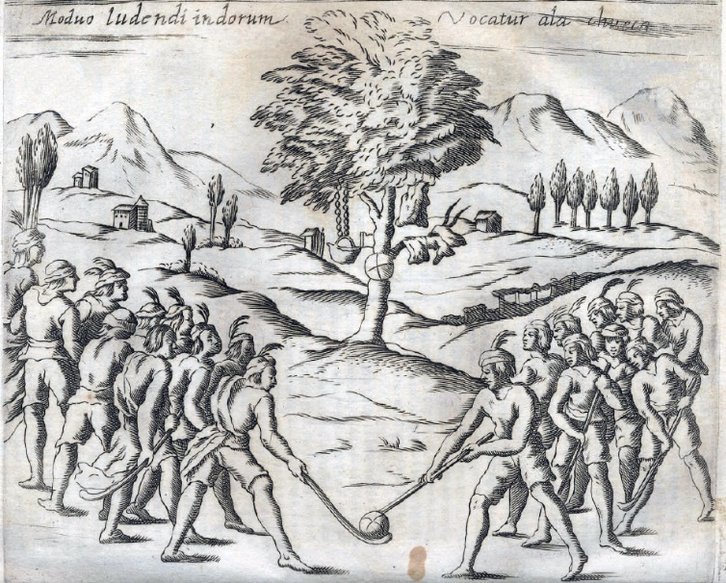  - Chilean natives playing “chueca”  - Modern hockey originated in England | - England is responsible for the spread of modern hockey  - Modern hockey was played and developed in the English public school system in the mid-18th and early in the 19th century  - The Blackheath & Old Elthamians Hockey Club is the oldest club in the world established in 1861  - 1876 there was an attempt to consolidate hockey as a formal sport and the first association was established,  - they drew up the first formal set of rules  - it only lasted 6 years  - 1886 the first “real” hockey association was created in London revived from the first  - Hockey diffused throughout the world as Brittan the British empire grew-  - The British would use it as a cultural bridge between locals and settlers (as well as other sports)  - British soldiers played  - The first international Hockey match took place in 1895 with British soldiers and Ireland beating Wales 3-0  - Men’s hockey first appeared in the Olympic games in 1908 in London  - Women’s hockey first appeared in the Olympics in 1980 in Moscow  - FIH was founded after the 1924 Paris Olympic Games representing hockey in Austria, Belgium, Czechoslovakia, France, Hungary, Spain, and Switzerland  - Now represents close to 91 countries
Focus Topic 1
Focus Topic 3
UGSHA  (Embraced) | Adaptive Hockey the Netherlands (Embraced)
- The Upper Great Southern Hockey Association (UGSHA)  Based in Narrogin  Teams come from-  - Williams  - Brookton  - Wagin  - Wickepin  - Pingelly  - Woodanilling (Joined 2021)  - Dumbleyung  - Senior competitions include both men’s and women’s A grade and B grade through the winter  - Junior competitions include Stick2Hockey (Yrs PP-1), J7 (Yrs 2-4), J11(Yrs 4-6), Middle school (Yrs 7-9) and Upper school(Yrs 10-12)  - Compete against other associations from around the state in tournaments such as-  - Country week  - Club champs  - Bunbury Carnival  - Host their own hockey carnival each year for school years 5-10  - Holds many clinics with professionals most often from the hockey roos  - Hosted international matches-  - Kookaburras vs Great Britain  - Kookaburras vs Netherlands | There are 2 Initiatives put in place by the Royal Dutch Hockey Association (KNHB):  - Initiative 1 is for players with learning disabilities and players with physical disabilities (that are not wheelchair bound) -  - The plan is for “The integration of able and disabled hockey players within out hockey clubs” and “the provision of structural activities and support for players with a disability”. -KHNB  - The first for hockey activities for players with learning disabilities was by the Zoetermeer hockey club in 1993  - 1996 the club “Push’ in Breda started activities for players with physical disabilities  - They adapt the rules; 6 a-side, quarter size fields, physically disabled players play with lighter balls and sticks and may have shortened field.  - As of 2010 62 clubs offer learning disability hockey, 12 clubs offer physical disability hockey (2 clubs offer both)  - Initiative 2 is for player with electric wheelchairs and hand moved wheelchairs-  - Wheelchair hockey started in the Netherlands in 1974  - As of 2010 Electric wheelchair hockey has 5 leagues with 60 teams from 27 clubs and hand moved wheelchairs have 7 leagues from 22 clubs  - 3 Teams from Belgium participate  - They have a number of activities including national tournaments, league games, annual tournaments, friendly matches and social activities  - They have had challenges in international co-operation’s and recognition

Focus Topic 4
Positive Implications | Negative Implications
People:  - Locally hockey tournaments (such as Upper Great Southern and Bunbury junior hockey carnivals) can bring a lot of money into local economies with visiting teams spending money on-  - Accommodation (eg local hotels, motels, caravan parks)  - Food (eg local grocery stores and restaurants)  - Entertainment  - Travel fees  - Physical benefits-  - Health in general such as increased body strength, developed cardiovascular system, improved co-ordination skills.  - Social benefits-  - Teamwork, communication | People:  - Hockey is considered an expensive sport for individuals to play-  - Parents on average spend $2000 annually  - Equipment costs include sticks, protective equipment (shin pads, mouthguards, masks, and gloves), bags, shoes, uniform, and bag.  - Other costs can include transport, accommodation, tournament fees, and club fees.  Places-  - In dry environments synthetic turfs use up to one litter of water per square meter every hour  - Hockey fields are 91m x 55m meaning a turf can use anywhere up to 5027 litters per hour

Focus Topic 2
Advancements in transport telecommunications | Role played by transnational institutions
Airplanes:  - Invented in the 20th century has been helping people cut the time taken to travel across land and sea  - Planes allows national teams to compete in competitions such as, FIH pro league  - Allow fans to go and watch international games and tournaments such as pro league and the Olympics  Containerisation:  - Containerisation- the transporting of cargo in containers (that can be interchanged between ships, trains and trucks) with standardised handling equipment and without rehandling the containers.  - Equipment (such as sticks, balls, shin pads ect) players need can be shipped from anywhere in the world-  - Eg. Gryphon manufactures it’s sticks in Pakistan and sells their sticks worldwide (big in countries like Australia and the Netherlands)  - Eg. Atlas the largest hockey stick producer in the world manufactures sticks in Taiwan then packages in China | Gryphon Hockey:  - In 2018 partnered with Hockey Dreams Foundation “to Make An Impact within our sport and support the development of sustainable communities”  - Gives children who may not be able to afford or access the resources the opportunity to play hockey  - Run projects in African countries (specifically Zambia) where-  - clinics for local children have been run  - Local coaches have been trained  - Hundreds of sticks, bags, apparel have been donated to Zambian communities  - Also partnered with the Hockey Dreams Foundation and the Timor Leste Hockey Federation to start a recycling programme in 2019-  - Australian ambassadors donate their gear which is still in useable condition  - Gear is then donated to places such as Timor Leste  - Because of this Hockey has become a popular sport in Timor Leste with Hockey Timor Leste becoming officially registered at the registration and notary of Timor Lest as a national sporting body  - Tim Howard “It's amazing as quite often we would go through 5 or 6 sticks in a year, however they would  still be in condition for someone else to use.

Focus Topic 5
Nature | Spatial Distribution
- The quality of hockey being play will improve and become more competitive with the improved grounds  - There may also be more adaptions to the sport as more people play it  - More rules may be added or changed-  - Rules are regularly reviewed before each hockey season with often rules being added, removed, or modified  - Eg. In 2020 it was made that players could no longer be as close as possible inside their defensive D if the opposition was taking a free hit outside the D, they now had to be 5 meters  - More ages will be included in local comps-  - There is already state master comps in state hockey for ages 35-75+ | - There will be more high-quality synthetic turfs especially in rural areas –  - Eg. Narrogin’s hockey turf installed in 2016, Northam in 2019  - Higher levels (Pro league, state) will be played outside of cities in places like Narrogin-  - Eg Narrogin has held 2 international games with the kookaburra’s vs Great Britain 2016 and the Netherlands 2018  - Hockey will become a sport more people can play and not just people from “wealthy” countries as costs will hopefully come down and equipment is donated through charities

